**Features of Amazon EC2**

Amazon EC2 provides the following features:

* Virtual computing environments, known as **instances**
* Preconfigured templates for your instances, known as **Amazon Machine Images (AMIs)**, that package the bits you need for your server (including the operating system and additional software)
* Various configurations of CPU, memory, storage, and networking capacity for your instances, known as **instance types**
* Secure login information for your instances using **key pairs** (**AWS stores the public key, and you store the private key in a secure place**)
* Storage volumes for temporary data that's deleted when you stop or terminate your instance, known as **instance store volumes**
* Persistent storage volumes for your data using **Amazon Elastic Block Store** (Amazon EBS), known as Amazon EBS volumes
* Multiple physical locations for your resources, such as instances and Amazon EBS volumes, known as **regions and Availability Zones**
* A firewall that enables you to specify the protocols, ports, and source IP ranges that can reach your instances using security groups
* Static IPv4 addresses for **dynamic cloud computing**, known as **Elastic IP addresses**
* Metadata, known as **tags**, that you can **create and assign to your Amazon EC2 resources**
* Virtual networks you can create that are logically isolated from the rest of the AWS cloud, and that you can optionally connect to your own network, known as **virtual private clouds** (VPCs)

Just as Amazon Simple Storage Service (Amazon S3) enables storage in the cloud, Amazon EC2 enables “compute” in the cloud.

We can create an AMI using the EC2, which allows setting and configuring everything about your instances from the operating system up to your applications.

An AMI is a packaged-up environment that includes all the necessary details to set up and boot your instance.

EC2 provides a number of tools to make creating an AMI easy. After creating a custom AMI, you have to bundle it. If you are bundling an image with a root device backed by Amazon EBS. You can simply use the bundle command in the AWS Management console.

If you are bundling an image with a boot partition on the instance store, then you need to use the AMI Tools to upload it to the Amazon S3.

EC2 uses amazon EBS and S3 to provide reliable, scalable storage of your AMIs so that you can boot whenever you want.

You can also use standard Linux distribution AMIs

SAAS – salesforce.com, office 365

IAAS – EC2 beta, Azure, google compute engine

PAAS

**Virtualization**

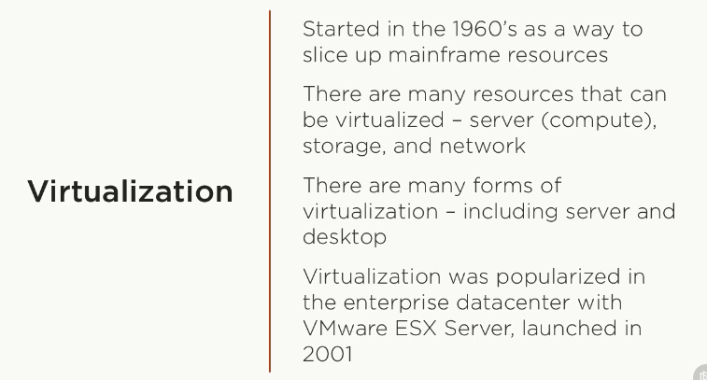

Running VMware in the windows is an example

**Hypervisor** is virtual machine monitor that allows us to create a virtual machine. The system on which hypervisor runs one or more virtual machine is the Host machine and each virtual machine is the **guest machine**. Example of the hypervisors are VMware Fusion, Oracle Virtual box etc.

Hypervisors can be divided into two types:

**Type 1**: Also known as native or bare-metal hypervisors, these run directly on the host computer’s hardware to control the hardware resources and to manage guest operating systems. Examples of Type 1 hypervisors include VMware ESXi, Citrix XenServer and Microsoft Hyper-V hypervisor.

**Type 2**: Also known as hosted hypervisors, these run within a formal operating system environment. In this type, the hypervisor runs as a distinct second layer while the operating system runs as a third layer above the hardware.